Reading: How do we sense different textures?

When we touch a material, we feel the texture of that material. We can tell if something is hard or soft just by placing our skin on the object. Have you ever considered how we can tell if something is hard or soft? It turns out the answer is deformation due to a contact force!

We learned in Lesson 5 that we can feel objects when the pressure sensors in our skin deform. We also learned these pressure sensors, or force detectors, are all over our body. It is estimated that you have roughly 150,000 of these in each hand! The special sensors for detecting force are called mechanoreceptors. Let’s learn more about how the skin senses different textures and softnesses.

The feeling of sharp vs. dull
When your finger touches a surface, part of your finger deforms. Things that feel sharper deform more of your finger and touch less surface area. Take a finger and touch your desk. Your finger touches the surface and then it starts to deform so that the entire pad of your finger is touching the surface of the desk. Now, take your pencil and use the point of your pencil to touch the pad of your finger. Does it feel different? The reason that the pencil feels sharper is because it makes your finger deform more and less surface area is in contact with the object. The table felt smooth or dull because it did not indent, or deform, your finger as much as the pencil point. The table also pressed on the whole pad of the finger, not just a small area. | 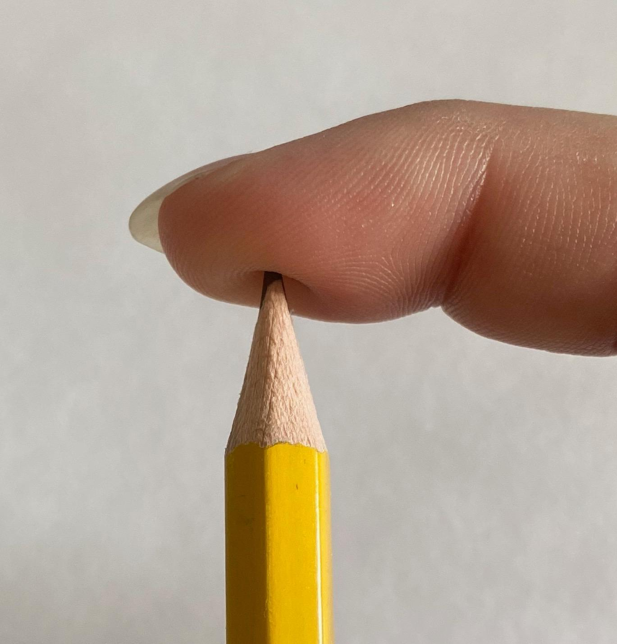  This pencil causes a lot of deformation to the pad of the finger, but it touches a very small surface area at the lead point. Because it touches such a small area and there is a large deformation, the brain senses this pencil as sharp.

The feeling of smooth vs. rough

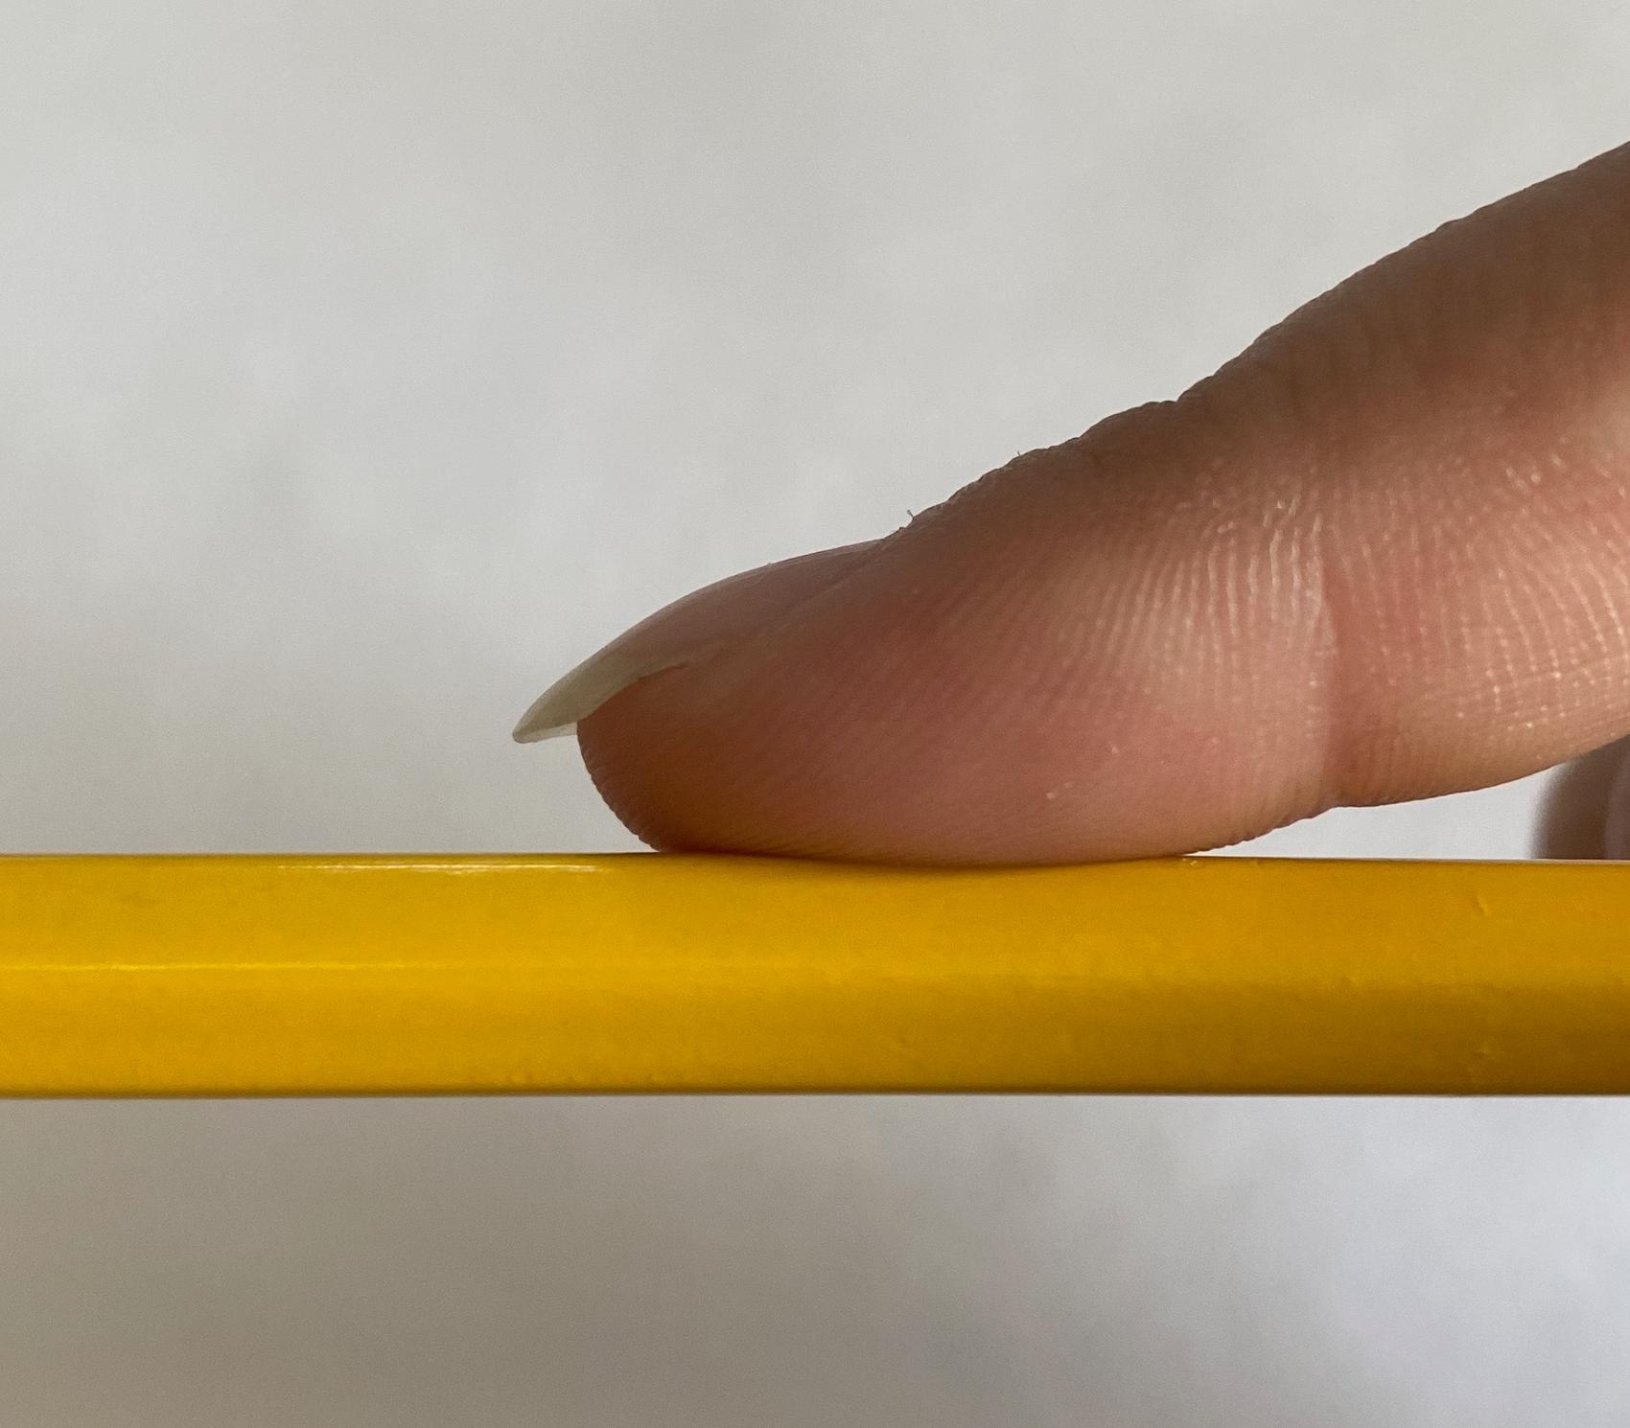  As the finger runs across this pencil, it does not encounter multiple areas of deformation and the pressure is consistent on the pad of the finger. This causes the brain to sense the pencil side as smooth. | When you run your hand across different surfaces, some feel smooth and others feel rough. Run your hand across a surface that is rougher, like the stitching on your backpack, a zipper, or the metal part of your pencil. Now run your hand across a surface that is smoother, like the top of your desk or the side of your pencil. Which one had more areas of deformation as you moved your finger across the surface? The rough surface makes many different spots on your finger deform as your finger moves across the surface, and the smooth surface does not have as many spots that cause deformation to the finger on multiple locations. The smooth surface does not deform your finger as much when your finger runs across the surface.

The feeling of soft vs. hard

When your hand touches something soft, the soft item deforms around your finger. The soft surface is deformed due to the pressure of your finger pushing on it. If your finger deforms the surface instead of the surface deforming your finger, it feels softer. Cotton balls feel soft because of how much they deform when we apply pressure. The surface touches a very large part of our fingertips with very little force being applied. Our bodies know when we are applying pressure, and the more we apply pressure without the resistance, the softer an object feels. | 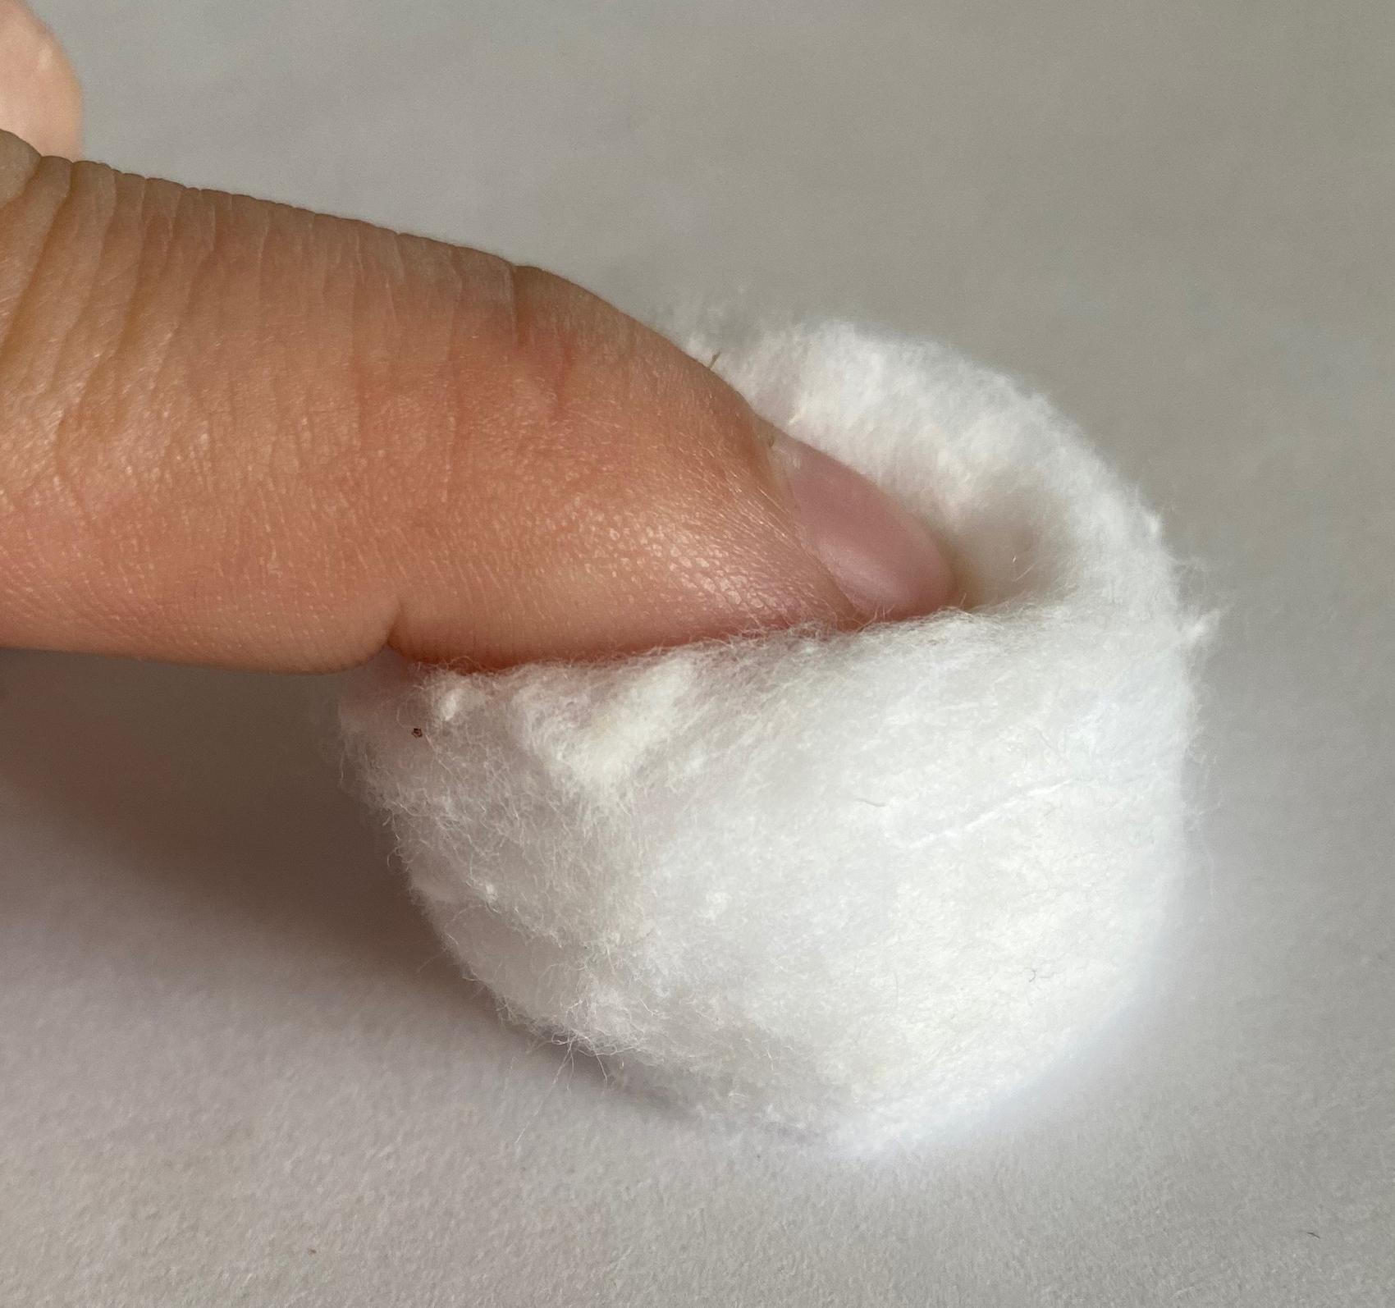  This cotton ball deforms when a contact force from the finger is applied. The finger senses that it is in contact with the cotton ball, and the cotton ball deforms more than the pad of the finger. This causes the brain to sense the cotton ball as soft.

How our brains receive the signal
Our sense of soft vs. hard depends on the amount of pressure and deformation on our skin. When the finger is deformed, it sends signals through our nerves to the brain that then interprets the texture of the objects. Our brain turns this signal into information that we can use.

